Pandemic EBT
F O R

Summer 2023

Background
The Summer 2023 plan for the Pandemic Electronic Benefit Transfer (P-EBT) is to issue a one-time $120 benefit to eligible students who are enrolled on the last day of SY 2022-2023. Local Education Agencies (LEAs) will be required to submit a Summer 2023 P-EBT student data file for all eligible students in early June. Details will be provided after the plan is approved by the USDA. Please note that Summer P-EBT will sunset in 2023.

Next Steps
Link your LEA website to the VDSS P-EBT webpage to provide information to parents and the community.

What to Expect in Summer 2024
Who is Eligible?
Students eligible for Summer 2023 P-EBT must:

- Be enrolled in a Virginia school as of the last day of SY 2022-2023, including recent graduates

- Attend a Virginia public or private school that participates in the USDA National School Lunch Program (NSLP)

- Be determined free or reduced-price (FRP) eligible for meals in the NSLP by direct certification or meal application
- O R -
- Be attending a Community Eligibility Provision (CEP) approved school

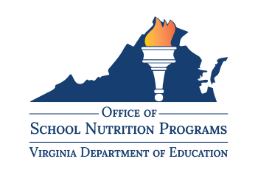A new, permanent Summer EBT program will begin in 2024. Beginning in Summer 2024, nutrition assistance funds will be issued each summer to an EBT card for all students eligible for FRP meals. Detailed USDA guidance will be issued by December 2023.
If you have questions or comments, please contact Lynne Fellin, Technical Advisor to the State Director, by email at Lynne.Fellin@doe.virginia.gov.
What will be the same? | What will be different?
Administration  - The Virginia Department of Education (VDOE) and Virginia Department of Social Services (VDSS) will continue to collaborate and partner with LEAs to implement Summer EBT.  School Notification  - Public school divisions and private School Food Authorities (SFA) operating the NSLP will submit a file of Summer EBT eligible students around the end of the school year. | Student Eligibility  - Students must have FRP eligibility by direct certification, meal application, or categorical eligibility to be eligible for summer EBT.  - CEP school enrollment will not automatically qualify students.  - States must provide an opportunity for students who meet the following criteria to apply for Summer EBT benefits:  - Do not attend a public NSLP school  - Attend CEP schools without individual  FRP eligibility

