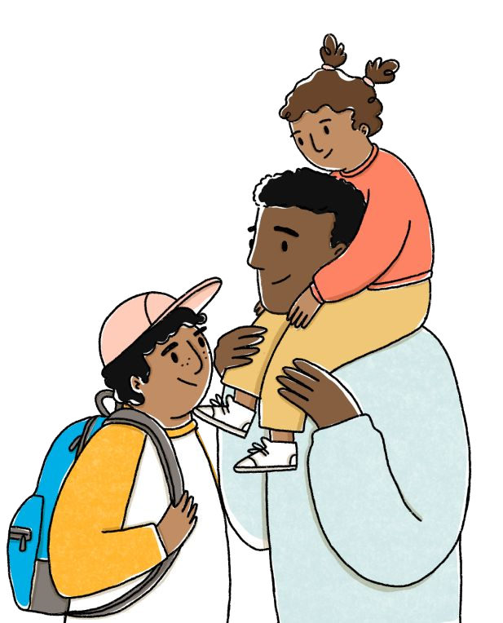
You could be eligible even if you have low or no income or don’t usually file taxes. More people are eligible to get this money than in other years. Sign up if you have not already filed a 2021 tax return
It's easy to apply!
Sign up by November 15th with a simple form at:
GetCTC.org
Does this money count as income for benefits I get?
How do I get this money?
This money does
not
count as income for most benefits, like SNAP, WIC, TANF, MEDICAID, CHIP, SSI and

most types of public and subsidized housing. You can get the tax payments and still get these benefits.

GetCTC.org is a non-profit service built by Code for America.
There’s still time to get your Child Tax
Credit, stimulus & other federal money!
Apply even if you have no income or low income
and don’t usually file taxes!
What could I get?
●
Up to
$3,600
per child with the 2021 Child Tax Credit,
●
Any missed stimulus payments for you and your
children/dependents -
up to $1,400 per person
●
Other payments if you had earnings last year
Am I eligible?
Sign up by November 15:

Families can be directed to getctc.org/VAschools to sign up.

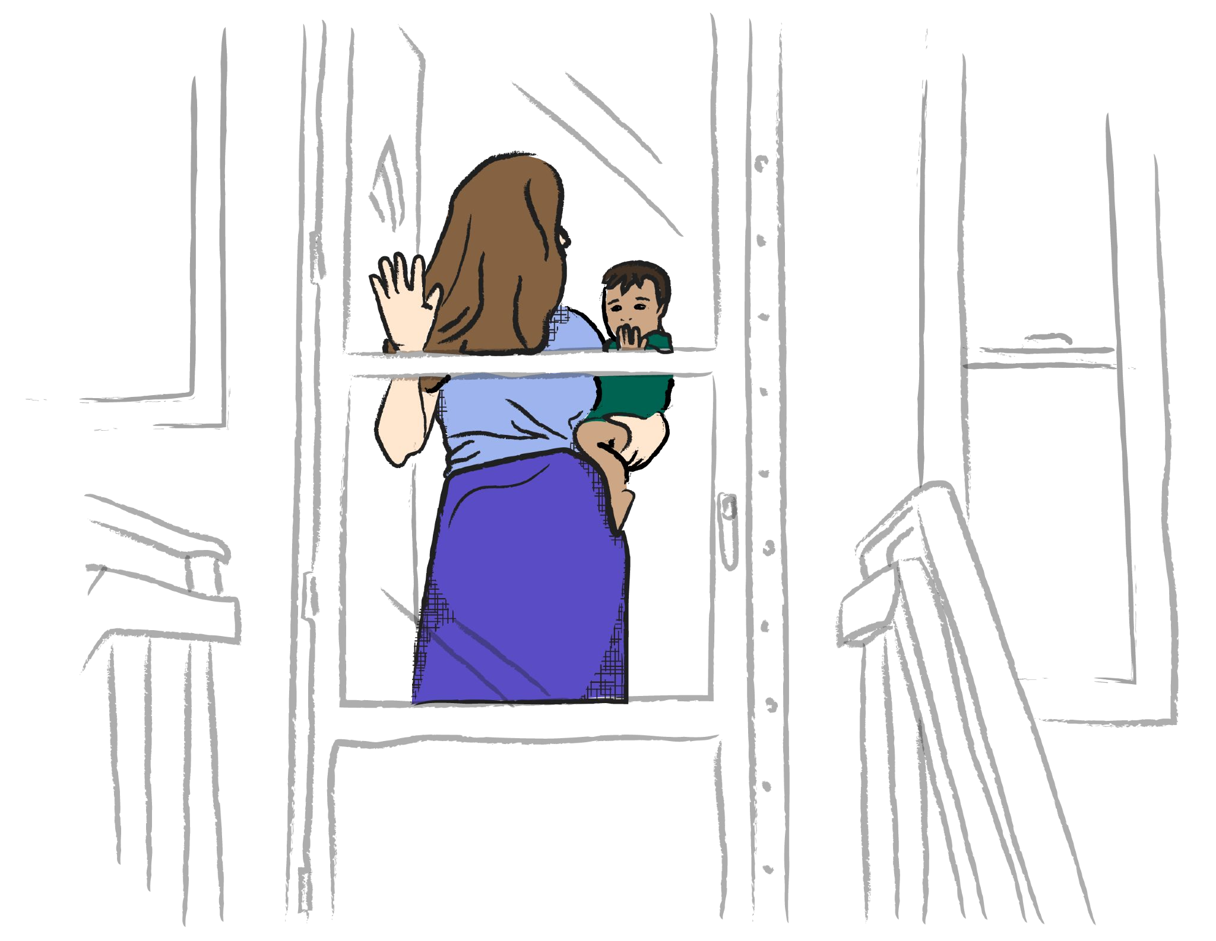
Families can be directed to getctc.org/VAschools to sign up.
What if I am an immigrant?
Even if you do NOT have a Social Security Number, you can get payments for your children who have Social
Security Numbers. Under current law, receiving the Child Tax Credit or other tax credits will not affect your
immigration status, ability to get a Green Card, or future immigration plans.
Had a baby in
2020
or 2021?
You should sign up!
Did you get monthly money from the IRS in 2021 for your
kids ($250 or $300 per month per child)?
That was just the
first part of your money. You have to sign up again in 2022 to
get the rest of your money.
Apply by November 15th:
GetCTC.org
GetCTC.org is a non-profit service built by Code for America.
Sign up by November 15:

